Ashcon Abae

Signals and Systems

October 22, 2019

MATLAB Project #1

* 1. *See Matlab code for part a*
  2. The length of the stem signal is L = 40, as given in array n.  
     From our graph, we can see the fundamental period = 10.
  3. The axis command fixes the x-axis and y-axis limits for the given axes.
  4. 2 types of grid command:  
     grid on displays grid lines for specified axes.  
     grid off removes grid lines and plots the output figure
  5. Plot joins neighboring points with one another, but stem plots discrete functions (i.e. without joining the coordinates)
  6. n = 0:50;

omega = 0.4*2*pi;

phase_offset = -pi/2;

A = 2.5;

xn = A*cos(omega*n + phase_offset);

stem(n,xn)

axis([0 40 -2.5 2.5]);

grid;

title("Discrete Time Sinusoid");

xlabel("Time index n");

ylabel("x(n)");

* 1. x = [1 2 -1 3 -1 0 0 0];  
     xm3 = [zeros(1,3) x(1:5)];  
     h = [2 0 2];  
     y1 = conv(x,h);  
     y2 = conv(xm3,h);  
     n = 0:9;  
     subplot(2,1,1);  
     stem(n,y1);  
     title('y_1[n] = x[n]*h[n]');  
     xlabel('n')  
     ylabel('y_1[n]');  
     subplot(2,1,2);  
     stem(n,y2);  
     title('y_2[n] = x[n-3]*h[n]');  
     xlabel('n')  
     ylabel('y_2[n]');  
     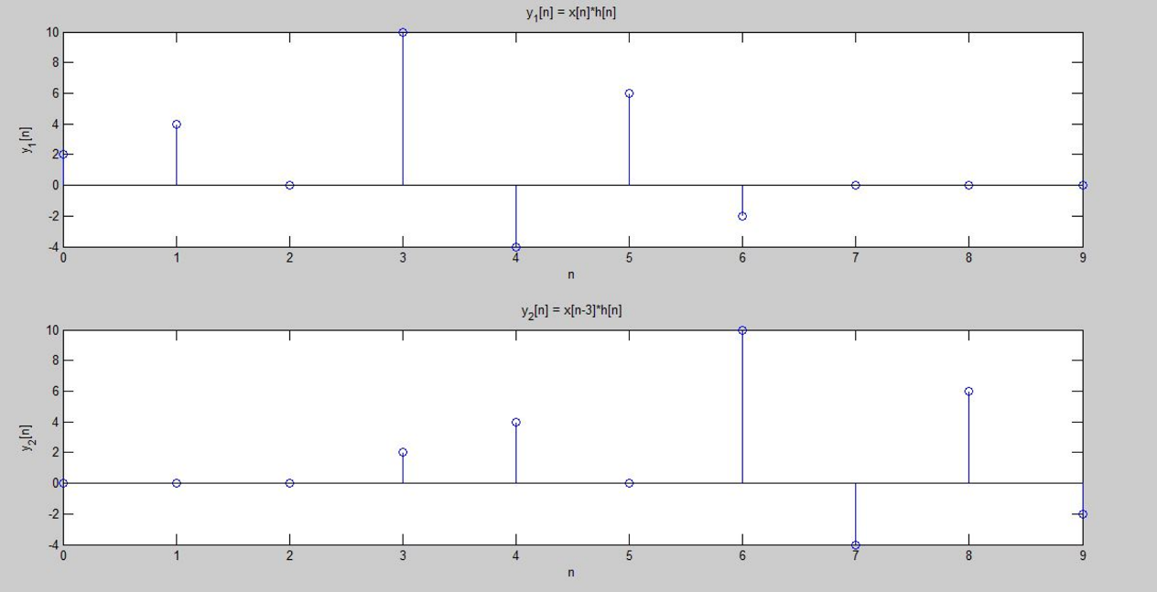
  2. I would guess that the system is time invariant because shifting the input by 3 units in time has shifted the same output by 3 units, hence no change in output characteristics.

1. t=[0:2*pi/1000:2*pi];  
   y1=((4/pi)*sin(t));  
   subplot(3,1,1)  
   plot(t,y1)  
   y2=(4/pi)*(sin(t)+(sin(3*t)/3));  
   subplot(3,1,2)  
   plot(t,y2)  
   y3=(4/pi)*(sin(t)+(sin(3*t)/3)+(sin(5*t)/5)+(sin(7*t)/7)+(sin(9*t)/9)+(sin(11*t)/11)+(sin(13*t)/13)+(sin(15*t)/15));  
   subplot(3,1,3)  
   plot(t,y3)  
   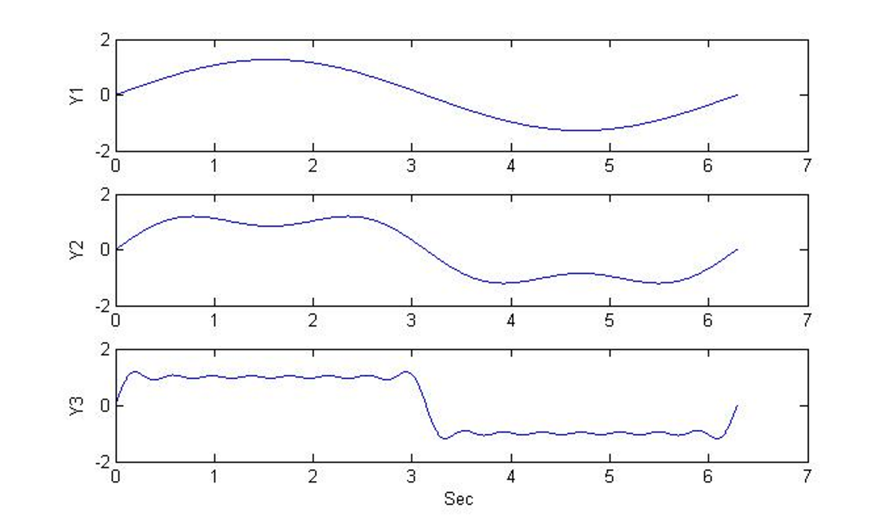
2. n=-8:1:8; % Defining values of n  
   ns=8;  
   % Calculation of Delta functions  
   dn=[zeros(1,ns),1,zeros(1,ns)]; % Calculation of Delta(n)  
   dn1=[zeros(1,ns+1),1,zeros(1,ns-1)]; % Calculation of Delta(n-1)  
   dn2=[zeros(1,ns+2),1,zeros(1,ns-2)]; % Calculation of Delta(n-2)  
   dn3=[zeros(1,ns+3),1,zeros(1,ns-3)]; % Calculation of Delta(n-3)  
   h1n=dn+dn1-dn2-dn3; % Calculation of function H1(n)

% Plot of H1(n)  
subplot(3,1,1);  
stem(n,h1n,'r');  
xlabel('Time');  
ylabel('Amplitude');  
title('Impulse response of discrete time system H1');

% Calculation of Step functions  
un=[zeros(1,ns),ones(1,ns+1)]; % Calculation of function u(n)  
un3p=[zeros(1,ns-3),ones(1,ns+4)]; % Calculation of function u(n+3)  
un3n=[zeros(1,ns+3),ones(1,ns-2)]; % Calculation of function u(n-3)  
un6n=[zeros(1,ns+6),ones(1,ns-5)]; % Calculation of function u(n-6)  
h2n=((1/2).^n).*(un3p-un3n); % Calculation of function H2(n)  
xn = ((1/4).^n).*(un-un6n); % Calculation of function X(n)

% Plot of H2(n)  
subplot(3,1,2);  
stem(n,h2n,'r');  
xlabel('Time');  
ylabel('Amplitude');  
title('Impulse response of discrete time system H2');

% Plot of X(n)  
subplot(3,1,3);  
stem(n,xn,'r');  
xlabel('Time');  
ylabel('Amplitude');  
title('Discrete time signal X');

% Program for question(B)  
n1v=-8;  
n2v=-8;  
vnfw=conv(xn,h1n); % Convolution of X(n) and H1(n) = V(n) in forward direction  
lv=length(vnfw);  
lv1=(n1v+n2v):((n1v+n2v)+lv-1);  
figure(2);  
subplot(2,1,1)  
stem(lv1,vnfw);  
xlabel('Time');  
ylabel('Amplitude');  
title('Convolution of x(n)*H1(n) = v(n)');  
n1y=n1v+n2v;  
n2y=-8;  
ynfw=conv(vnfw,h2n); % Convolution of V(n) and H2(n) = Y(n) in forward direction  
ly=length(ynfw);  
ly1=(n1y+n2y):((n1y+n2y)+ly-1);  
subplot(2,1,2)  
stem(ly1,ynfw);  
xlabel('Time');  
ylabel('Amplitude');  
title('Convolution of v(n)*H2(n) = y(n)');

% Program for question(C)  
vnbw=conv(xn,h2n); % Convolution of X(n) and H2(n) = V(n) in backward direction  
lv=length(vnbw);  
lv1=(n1v+n2v):((n1v+n2v)+lv-1);  
figure(3);  
subplot(2,1,1)  
stem(lv1,vnbw,'g');  
xlabel('Time');  
ylabel('Amplitude');  
title('Convolution of x(n)*H2(n) = v(n)');  
n1y=n1v+n2v;  
n2y=-8;  
ynbw=conv(vnbw,h1n); % Convolution of V(n) and H1(n) = Y(n) in backward direction  
ly=length(ynbw);  
ly1=(n1y+n2y):((n1y+n2y)+ly-1);  
subplot(2,1,2)  
stem(ly1,ynbw,'g');  
xlabel('Time');  
ylabel('Amplitude');  
title('Convolution of v(n)*H1(n) = y(n)');  
  
